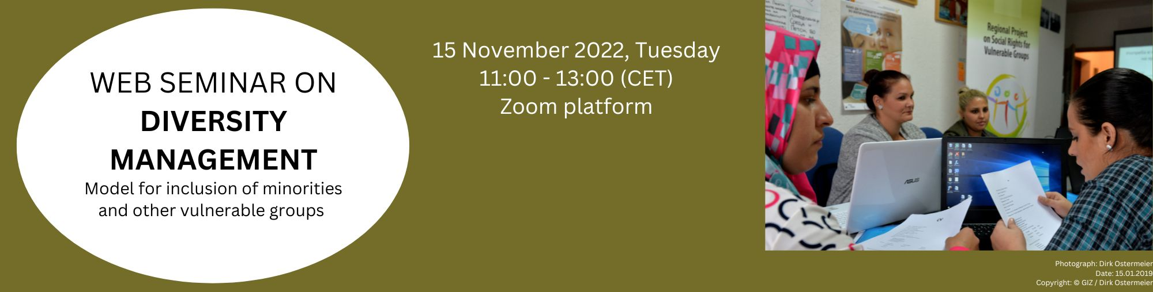

AGENDA
Registration link: https://us06web.zoom.us/webinar/register/WN_hDZkcePFRp61Y26JdbEYFw
Diversity Management:
Model for inclusion of minorities and other vulnerable groups
Moderation: Joachim Roth (NALAS)

Time | Session
10:45 – 11:05 | Check-in of Participants and instructions on Zoom Web seminar features
11:05 – 11:15 | Welcome by Schleswig-Holstein, GIZ and NALAS | Ms. Linda Pieper – State Chancellery Federal State of Schleswig-Holstein  Ms. Fenna Oldendoerp – GIZ office Hamburg  Petrit Sopjani – Thematic Advisor GIZ Kosovo  Joachim Roth – NALAS EU Officer
11:15 – 11:20 | Diversity & Diversity Management Presentation by NALAS | Elaborated by Dr. Zora Popova, former Project Leader “Teaching in Diversity”, Erasmus+ KA2 strategic partnership
11:20 – 11:30 | Participant interaction  Opinion poll
11:30 – 12:00 | Diversity management in Municipality of Bitola  Diversity Management in Municipality of Delcevo | Ms. Simona Jovevka  Ms. Suzana Petrovska
12:00 – 12:10 | Break
12:10 – 12:25 | DIVERSITY MANAGEMENT: Model for inclusion of minorities and other vulnerable groups  Presentation | Gordana Nestorovska and Memet Memeti – Matter experts
12:25 – 12:30 | Video – Diversity Management
12:30 – 12:45 | Diversity Management – challenges, opportunities and lessons learned  Virtual Panel Discussion | Gordana Nestorovska & Memet Memeti, Experts
12:45 – 13:00 | Q&A with participants
13:00 – 13:10 | Project expected results and benefits for the municipalities, next steps | Joachim Roth
13:10 – 13:15 | End of the Web Seminar

